Ideation Phase
Define the Problem Statements

Date | 27 June 2025
Team ID | LTVIP2025TMID36160
Project Name | Citizen AI – Intelligent Citizen Engagement Platform
Maximum Marks | 2 Marks

Customer Problem Statement Template:
Create a problem statement to understand your customer's point of view. The Customer Problem Statement template helps you focus on what matters to create experiences people will love.
A well-articulated customer problem statement allows you and your team to find the ideal solution for the challenges your customers face. Throughout the process, you’ll also be able to empathize with your customers, which helps you better understand how they perceive your product or service.

Example:
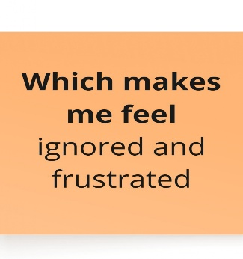
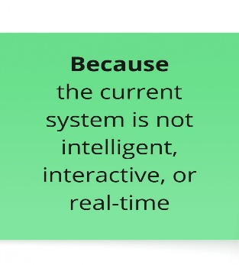
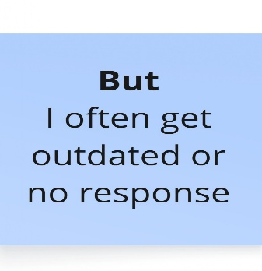
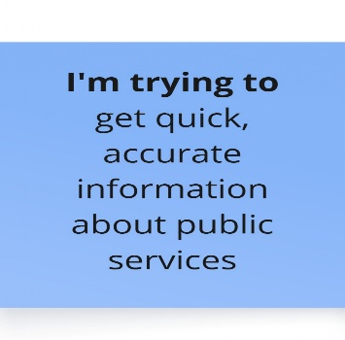
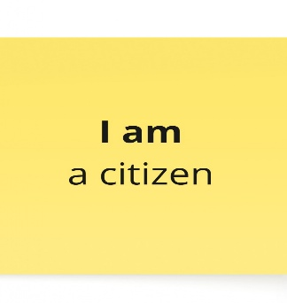

Problem Statement (PS) | I am (Customer) | I’m trying to | But | Because | Which makes me feel
PS-1 | A citizen trying to access government service information online | Get accurate and quick answers about policies and services | The official websites are hard to navigate and have outdated information | There’s no centralized, user-friendly, or real-time system in place | Frustrated, unheard, and discouraged from engaging with the government
PS-2 | A government official responsible for monitoring public feedback | Understand citizen sentiment and service satisfaction in real-time | Collecting and analyzing feedback manually is slow and ineffective | Current systems lack AI-powered automation and insights | Overwhelmed, disconnected from citizen needs, and unable to make timely improvements

